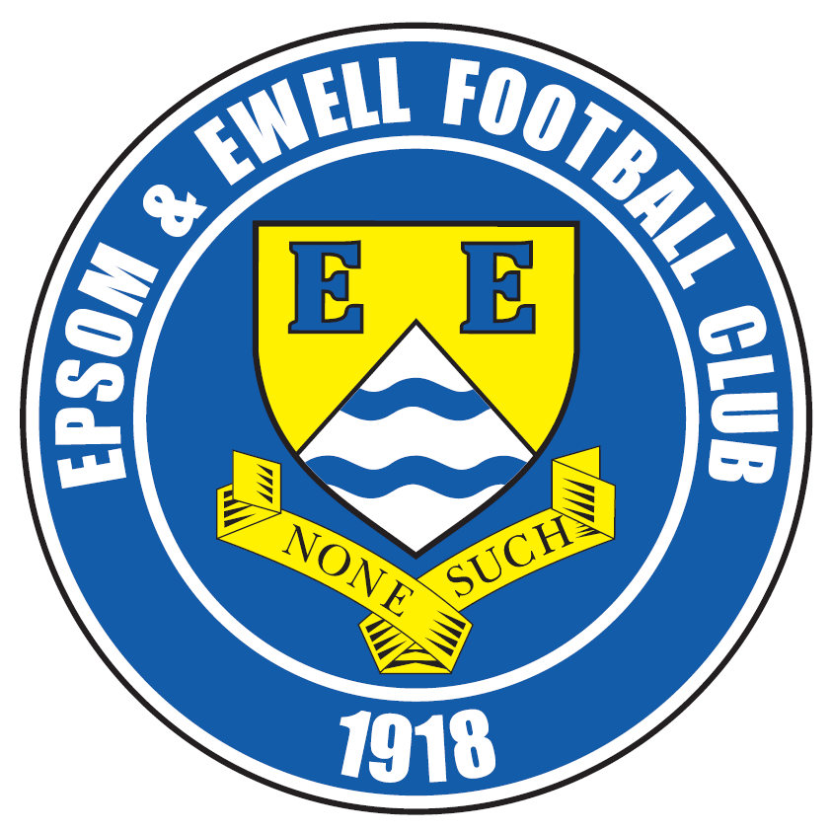 | Epsom & Ewell F.C.  17  v  Ashford Town (Mx)  Tuesday, 12th January 2016 – 7.45p.m.
Good evening and a belated Happy New Year! We welcome the players, supporters and officials of Ashford Town (Mx) Football Club, together with today’s match officials and our own regular supporters for a Third Round League Cup tie.

Matches against our opponents have historically resulted in poor results for us, although the last two meetings have gone our way, both at Short Lane. We won 3-1 there last January and again 3-2 back in October. However, we have to go all the way back to 26th October 2002 for our last home win by three clear goals in the Ryman League, so we know this will be a difficult cup tie. We are of course also locked in battle near the top of the table and will meet again here for the final game of the season on Saturday 30th April. Hopefully there will still be lots riding on that match.

We were due to face Redhill here last week, but we suffered our first Saturday rain induced postponement at Chipstead in the four seasons we have been here. Admittedly it was very heavy rain and congratulations should go to any clubs who managed to get their games played, of which tonight’s opponents were one. We then suffered another postponement at AFC Hayes on Saturday.

We were last in action at Chipstead back before Christmas when Sutton Common Rovers visited, and a spectacular three goal burst early in the second half did the damage. A 90th minute consolation was the least they deserved though, as they matched us for large periods of the game, but the goals we are scoring these days are almost all worthy of a highlight reel! Reisse Griffin opened the scoring with a scintillating volley before Rob Hendry clinically took advantage of a defender error and then Tom Neale smashed one into the top corner from 30 yards.

After that we travelled to Horley Town on the Bank Holiday Monday morning, where we had our usual contentious and feisty match! This time it was the opposition that had a man sent off as we turned a 1-0 deficit into a 2-1 lead before being pulled back by a late penalty and drawing 2-2. We may well have to wait until the end of the season before we find out whether those dropped points will cost us, but I thought a draw was a fair result over the ninety minutes.

We are back here again on Saturday when Spelthorne Sports are the visitors. We won 6-2 over there but they are much improved since then and we will have to work hard if we are to complete a league double.

All that remains to be said is that tonight’s match could go to extra time and maybe even penalties should the scores remain level.

Enjoy the game!

Rich

You can now follow us on Facebook www.facebook.com/epsomandewellfc or Twitter @EEFCOfficial

Cover Photos by Gemma Jarman

- Look out Gemma! The ball heads for our photographer in the match v SCR
- Kyle Hough strokes our second penalty away against Horley Town


Cherry Red Records Combined Counties League
Premier Division Table 2015/16
inc Saturday 9th January | P | W | D | L | F | A | Pts | GD | H | A
Ashford Town (Mx) | 23 | 18 | 1 | 4 | 61 | 30 | 55 | +31 | 30/4 | 3-2
Hartley Wintney | 21 | 17 | 2 | 2 | 66 | 21 | 53 | +45 | 30/1 | 3-3
Epsom & Ewell | 22 | 14 | 6 | 2 | 54 | 20 | 49 | +34 | X | X
Camberley Town | 20 | 14 | 3 | 3 | 40 | 17 | 45 | +23 | 16/4 | 20/2
Colliers Wood United | 26 | 12 | 2 | 12 | 53 | 43 | 38 | +10 | 3-1 | 3-0
Hanworth Villa | 22 | 12 | 2 | 8 | 41 | 34 | 38 | +7 | 5-0 | 23/4
Horley Town | 20 | 11 | 4 | 5 | 50 | 29 | 37 | +21 | 27/2 | 2-2
Windsor | 23 | 8 | 8 | 7 | 41 | 42 | 32 | -1 | 2-2 | 23/1
Spelthorne Sports | 22 | 9 | 5 | 8 | 40 | 43 | 32 | -3 | 16/1 | 6-2
Sutton Common Rovers | 24 | 9 | 3 | 12 | 44 | 47 | 30 | -3 | 3-1 | 2-1
Raynes Park Vale | 23 | 9 | 2 | 12 | 46 | 49 | 29 | -3 | 3-1 | 28/3
AFC Hayes | 24 | 8 | 4 | 12 | 36 | 44 | 28 | -8 | 1-1 | ???
Guildford City | 23 | 8 | 3 | 12 | 46 | 57 | 27 | -11 | 4-0 | 2/4
Knaphill | 19 | 8 | 2 | 9 | 36 | 32 | 26 | +4 | 12/3 | 1-1
Farnham Town | 21 | 7 | 4 | 10 | 35 | 35 | 25 | 0 | 1-0 | 6/2
Westfield | 17 | 6 | 6 | 5 | 23 | 26 | 24 | -3 | 26/3 | 0-0
Chessington & Hook | 23 | 7 | 2 | 14 | 40 | 55 | 23 | -15 | 1-0 | 19/3
Bedfont Sports | 21 | 5 | 7 | 9 | 29 | 32 | 22 | -3 | 13/2 | 2-2
Badshot Lea | 21 | 7 | 1 | 13 | 26 | 53 | 22 | -27 | 9/4 | 1-0
Chertsey Town | 22 | 5 | 5 | 12 | 22 | 36 | 20 | -14 | 0-1 | 5/3
Redhill | 18 | 3 | 3 | 12 | 23 | 43 | 12 | -20 | 2/2 | 1-0
Cove | 17 | 1 | 0 | 16 | 9 | 73 | 3 | -64 | 15/3 | 7-0

Lucky Day? – 12th January
Played 12 - W 7 D 2 L 3 - F 26 A 17 - PPG 1.92 - Very Good
Our Club record against Ashford Town (Mx)
Played 16 - W 4 D 2 L 10 - F 22 A 41 - PPG 0.88 - Very Poor
Largest wins and losses against Redhill
26th October 2002 - (H) W 3-0 - League - 23rd September 2003 - (H) L 0-5 - League
Their Last visit
Saturday 18th October 2014 - L 2-4 - Combined Counties League

Club Manager - Glyn Mandeville
Good afternoon everyone and welcome to tonight’s game against Ashford Town. I do hope everyone had a great Christmas and New Year.

We come into this game after a very good year, only losing once in the league and remaining unbeaten away from home. The lads have worked so hard so far this season and we hope to carry on in the New Year.

We are still missing players through injury and hope to get them back fit soon.

I hope you enjoy this evening’s game and have a safe trip home.

Cheers for all your support.

Manders

Club Captain - Sam Currie
Good evening and welcome to our Cup match against Ashford Town.

After our game against Horley, which we knew would be a tough one and it didn't let us down - particularly with the pitch condition - we were a little disappointed to come away with only the one point, having led in the game late on, only to see a harsh penalty awarded which meant that we were unable to do this.

This means we will be looking to hopefully put things right this evening and provide a performance that is worthy to get back on the winning track.

We know things won't be easy and will again have to be at our best as Ashford are rivals for both the League and the League Cup.


Therefore, we hope you’re in for a good game and on behalf of the squad, I wish you all a happy New Year and a safe journey home following this evening’s match.

Sam

Latest Results and Fixtures
Combined Counties League – Saturday 19th December
AFC Hayes | 0-5 | Ashford Town (Mx)
Badshot Lea | 1-3 | Farnham Town
Bedfont Sports | 2-1 | Camberley Town
Colliers Wood United | 5-2 | Knaphill
Epsom & Ewell | 3-1 | Sutton Common Rovers
Guildford City | 4-2 | Chertsey Town
Hartley Wintney | 2-0 | Hanworth Villa
Raynes Park Vale | 2-3 | Horley Town
Windsor | 1-1 | Spelthorne Sports
Combined Counties League – Tuesday 22nd December
Sutton Common Rovers | 3-0 | Redhill
Combined Counties League – Monday 28th December
Ashford Town (Mx) | 2-1 | Windsor
Camberley Town | 3-1 | Hartley Wintney
Chertsey Town | 0-1 | Colliers Wood United
Farnham Town | 2-2 | Guildford City
Hanworth Villa | 2-1 | Bedfont Sports
Horley Town | 2-2 | Epsom & Ewell
Raynes Park Vale | 3-2 | Chessington & Hook United
Spelthorne Sports | 3-2 | AFC Hayes
Combined Counties League – Saturday 2nd January
Ashford Town (Mx) | 6-4 | Knaphill
Camberley Town | 3-0 | Chessington & Hook United
Epsom & Ewell | p-p | Redhill
Sutton Common Rovers | 2-1 | AFC Hayes
F.A. Vase Fourth Round – Saturday 9th January
FC Romania | 1-2 | Camberley Town
Hartley Wintney | p-p | Bradford Town
Kidlington | p-p | Knaphill
Combined Counties League – Saturday 9th January
AFC Hayes | p-p | Epsom & Ewell
Spelthorne Sports | 6-2 | Badshot Lea
Windsor | 0-1 | Colliers Wood United
Combined Counties League Cup – Tuesday 12th January
Camberley Town | V | Spelthorne Sports
Cobham | V | Frimley Green
Epsom & Ewell | V | Ashford Town (Mx)
Latest Results and Fixtures
Surrey Senior Cup – Tuesday 12th January
Whyteleafe | V | Farnham Town
Combined Counties League – Tuesday 12th January
Horley Town | V | Hartley Wintney
F.A. Vase Fourth Round – Saturday 16th January
Hartley Wintney | V | Bradford Town
Kidlington | V | Knaphill
Combined Counties League – Saturday 16th January
Badshot Lea | V | Windsor
Chertsey Town | V | Chessington & Hook United
Colliers Wood United | V | Westfield
Cove | V | Farnham Town
Epsom & Ewell | V | Spelthorne Sports
Guildford City | V | Horley Town
Hanworth Villa | V | AFC Hayes
Raynes Park Vale | V | Redhill

Player Profile – Number 11 – Reisse Griffin

Our latest player profile is from another of our new players this season, Reisse Griffin.

Age: 25

Position: Winger

Club supported: Arsenal

Favourite Food: Curry

Favourite Film: Jump Street

Messi or Ronaldo: Ronaldo

Favourite Drink: Red Bull

Favourite Holiday Destination: Las Vegas

Favourite Ground played at: Stamford Bridge, Chelsea FC

Best Moment for Epsom & Ewell: My first goal for the club!

Describe the Gaffa in three words: Funny – Good-looking – Tall

Reisse’s Playing Stats: First Team Debut : 08/08/2015

Appearances: 11 - Sub: 4 - Total: 15 - Goals: 1

First Eleven Appearances - (max 26 – including Horley Town – 28/12/15)
Name | Debut | 2014/15 |  |  |  | Career Totals
Name | Debut | App | Sub | Total | Goals | App | Sub | Total | Goals
AJAYI Tayo | 22/08/2015 | 0 | 2 | 2 | 0 | 0 | 2 | 2 | 0
COOPER-SMITH Daryl | 03/01/2015 | 15 | 4 | 19 | 8 | 24 | 7 | 31 | 14
CURRIE Sam | 04/08/2012 | 16 | 1 | 17 | 1 | 124 | 10 | 134 | 3
DAVISON Conor* | 22/08/2015 | 1 | 2 | 3 | 0 | 1 | 2 | 3 | 0
DEAN Dan | 02/08/2014 | 17 | 2 | 19 | 0 | 53 | 3 | 56 | 0
DOWNS Carl | 17/09/2011 | 4 | 1 | 5 | 0 | 98 | 14 | 112 | 2
EACOTT Michael | 02/08/2014 | 23 | 0 | 23 | 0 | 69 | 0 | 69 | 0
FARRELL Matt | 02/08/2014 | 25 | 0 | 25 | 5 | 66 | 3 | 69 | 12
FERDINANDO Matt | 20/09/2014 | 17 | 0 | 17 | 5 | 44 | 4 | 48 | 11
GRIFFIN Reisse | 08/08/2015 | 11 | 4 | 15 | 1 | 11 | 4 | 15 | 1
HASTINGS Craig | 08/08/2015 | 19 | 3 | 22 | 0 | 19 | 3 | 22 | 0
HENDRY Rob | 08/08/2015 | 22 | 3 | 25 | 9 | 22 | 3 | 25 | 9
HOUGH Kyle | 14/08/2007 | 20 | 2 | 22 | 17 | 316 | 17 | 333 | 188
JONES Adrian | 06/08/2011 | 2 | 0 | 2 | 0 | 22 | 0 | 22 | 0
KURDZIEL Jakub | 29/08/2015 | 1 | 0 | 1 | 0 | 1 | 0 | 1 | 0
MARVELL Dale* | 15/01/2000 | 8 | 4 | 12 | 1 | 269 | 49 | 318 | 86
MCGREGOR Alex | 08/08/2009 | 7 | 2 | 9 | 2 | 179 | 58 | 237 | 29
MCKAY Alex | 20/12/2008 | 17 | 1 | 18 | 0 | 102 | 27 | 129 | 8
NEALE Thomas | 13/10/2015 | 6 | 8 | 14 | 4 | 6 | 8 | 14 | 4
NEILL David* | 03/10/2015 | 1 | 1 | 2 | 0 | 1 | 1 | 2 | 0
NORTH Rhys | 16/08/2015 | 8 | 6 | 14 | 0 | 8 | 6 | 14 | 0
OLIVER Beckett | 29/08/2015 | 5 | 10 | 15 | 0 | 5 | 10 | 15 | 0
PANAYIOTOU Savvas | 03/01/2015 | 2 | 2 | 4 | 0 | 18 | 5 | 23 | 3
ROWE Steve | 27/08/2011 | 0 | 1 | 1 | 0 | 24 | 3 | 27 | 0
SMITH Matt | 08/08/2009 | 0 | 0 | 0 | 0 | 91 | 43 | 134 | 10
TANTON Matt | 02/08/2014 | 22 | 0 | 22 | 0 | 40 | 4 | 44 | 1
TAYLOR James | 26/08/2013 | 17 | 2 | 19 | 2 | 73 | 10 | 83 | 5
Own Goal |  |  |  |  |  |  |  |  | 1
* Player has left the club

EL Records Premier Challenge Cup
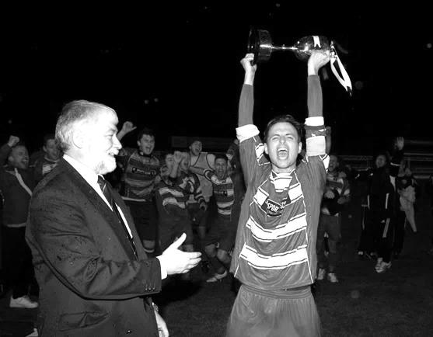
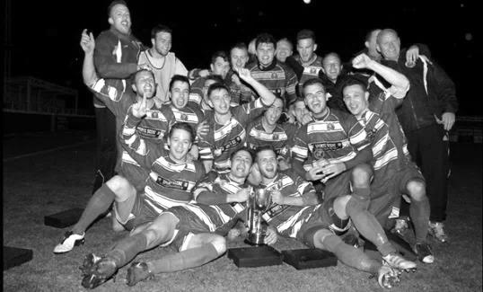
Second Round
Dorking Wanderers | 2-1 | South Park Reserves
Westfield | 1-0 | CB Hounslow United
Bedfont & Feltham | 1-5 | Colliers Wood United
Dorking | 0-3 | Knaphill
Badshot Lea | 2-4 | Spelthorne Sports
Hanworth Villa | 1-2+ | Chertsey Town
Ashford Town (Mx) | 2-1 | Epsom Athletic
Hartley Wintney | 4-2 | Horley Town
Banstead Athletic | 1-1+ | Epsom & Ewell
Epsom & Ewell won 7-6 on penalties
Sheerwater | 3-3+ | Frimley Green
Frimley Green won 8-7 on penalties
Farnham Town | 3-2 | Abbey Rangers
Camberley Town | 4-2 | Eversley & California
AFC Hayes | 0-1 | Banstead Athletic
Redhill | 3-0 | Sutton Common Rovers
Worcester Park | 1-5 | Chessington & Hook United
Cove | 1-6 | Cobham
Third Round
Camberley Town | 12/1 | Spelthorne Sports
Cobham | 12/1 | Frimley Green
Redhill | 9/2 | Farnham Town
Raynes Park Vale | 16/2 | Westfield
Epsom & Ewell | 12/1 | Ashford Town (Mx)
Colliers Wood United | 6-0 | Dorking Wanderers Reserves
Knaphill | 16/2 | Chertsey Town
Hartley Wintney | 2/2 | Chessington & Hook United

From behind the goal
Epsom & Ewell 3-1 Sutton Common Rovers
Combined Counties League - Premier Division - Saturday 19th December 2015

Rovers seen off by second half blitz

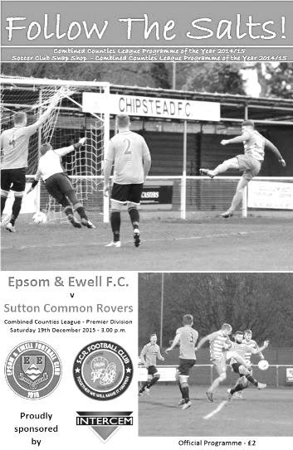
We negotiated a tricky hurdle on Saturday when they defeated Sutton Common Rovers by three goals to one. This was a tough looking fixture based on the visitors’ recent form and it took us until the second half before we were able to show our own quality, blowing the opponents away with three ferocious strikes to add to our already impressive number of spectacular goals this season.

We were no doubt going to be fielding an unchanged eleven from last Saturday's win, until Friday night's car accident involving Tom Neale and Matt Ferdinando. Our match winner from last week was battered and bruised and unable to take part in this match, although should be fine by the time our next game comes around, while Neale was in better shape and started on the bench but would come onto the field to great effect later. Matt Tanton and Rob Hendry came into the starting eleven instead so we were still very strong, although there was still no sign of the injured James Taylor or Sam Currie.

The first half was a bit of an anti-climax really. Losing the toss and going against the wind, there was every hope that we could turn around with a healthy lead as was the case against Guildford City two weeks previously, but there was no way this was going to happen against a committed and competitive Rovers team, buoyed by their F.A.Vase win just seven days previously. In fact the visitors shaded possession in the first half, although there were few in the way of real chances. It was a half of nearly and not quite, as first the visitors squared a dangerous ball across our goal but there was no one there to apply the finishing touch, while moments earlier an Alex McKay delivery was just too high for Matt Farrell, who would have only required the slightest header to defeat the exposed keeper Harvey Cheadle, brother of former Epsom players Jordan and Adam.

Tanton, playing in an advanced left midfield role on his return from suspension had a good opportunity but was unable to lift his shot over the keeper from the edge of the area. Less than a minute later it was our turn to breathe a sigh of relief as a speculative attempt from out on the Sutton left cleared our bar by inches with Michael Eacott unable to get there.

We had our best opportunity in the 32nd minute when Kyle Hough intercepted a clearing header and cut in from the left corner of the area, but whilst his shot was good enough to beat the keeper it was cleared off the line by Anson Collins. A couple of corners followed and Reisse Griffin saw his low effort palmed away for another set piece which Dan Dean was then almost able to make contact with. It was clear that we were the more dangerous side going forward but we hadn't done as much of it as the visitors who were making a real game

of it and required Eacott to come out quickly and make a good save just before the half.

Unfortunately during the first half McKay fell awkwardly and at the break he was replaced by Tom Neale with Tanton reverting to left back. Arguably this gave us a little more balance and it took just six minutes of the second period before we were ahead, but what a goal it was, starting with Hendry, who found Hough on the left hand side near the penalty area. He beat his man and burst into the box before laying the ball back into the path of Farrell, who produced a super left footed cross over everyone and almost beyond Griffin at the far post, but our man stretched and hit a scintillating volley into the roof of the net from 12 yards, giving Cheadle no chance. What a way to score your first competitive goal for the club!

Five minutes later we had extended our lead. A defensive error was pounced upon by Hendry and from the edge of the box, he curled a left footed shot just inside Cheadle's right hand post. Game over, it appeared. Of course it should be remembered that Sutton Common Rovers were 2-0 down the previous week before fighting back to win and they sparked into life. Eacott made a good save with his feet from Francois Gabbidon and it was clear that we just needed to weather the storm for five minutes, but no one told Neale who received the ball thirty yards out and promptly lashed the ball into the top corner to make it 3-0 to the Salts in the 59th minute.

Shortly after this Rhys North, having been injured earlier in the match, picked up another knock and was replaced by the returning Savvas 'Agi' Panayiotou with Griffin dropping to right back. Despite him playing further back now, he almost scored again after 69 minutes when a cross was picked up by the wind and missed the top corner by a matter of feet.

Unfortunately, Tanton picked up a booking for a shirt pull in the 73rd minute and then just two minutes later cleared the ball away just after the referee had awarded a free kick against us. It was a little after the whistle and probably deserving of a yellow card, although on many other occasions the player would have received the benefit of the doubt, but not this time, so our full back made the short walk back to the dressing room a little earlier than intended.

The visitors put on two substitutes, pushing forward in an attempt to reduce the deficit and the game was stretched for a while as a result. We had a great opportunity to extend our lead when Cheadle flapped at a high ball under pressure from Neale and the loose ball fell to Farrell but he shot wide, while at the other end, two attempts were blocked but not a third as Arnold Okiror scored from close range in the 90th minute to end our run of games without conceding at three, instead of the four it so nearly was.

This was a disappointing ending but ultimately it made no difference to the most important thing, the result, and I would be more than happy to concede a late goal every week if we were already 3-0 up by then! Overall though the opposition did deserve something out of this game and a three clear goal win would have been harsh on them. For us, we will have to produce our best form for the full ninety minutes when we visit Horley Town, another of the top five on the Monday Bank Holiday, or we may pay a heavy price.

Team: Michael Eacott, Rhys North, Alex McKay, Dan Dean, Craig Hastings, Carl Downs, Matt Tanton, Matt Farrell (c), Kyle Hough, Rob Hendry, Reisse Griffin

Subs: Tom Neale for McKay (45), Savvas 'Agi' Panayiotou for North (62)

From behind the goal
Horley Town 2-2 Epsom & Ewell
Combined Counties League - Premier Division - Monday 28th December 2015

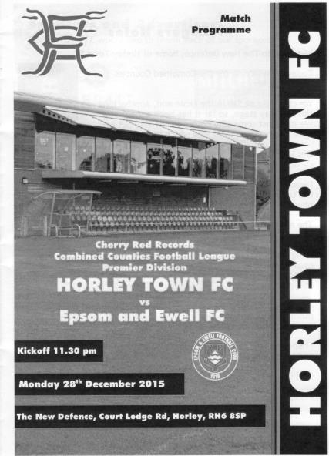
A chance missed - or a point gained?

Matches between Horley and ourselves are frequently incident packed and whilst the first half was fairly quiet by past standards, the second more than made up for it as both teams ended up with a point from their endeavours, but might feel they deserved more.

We only made one change to the starting eleven from the win over Sutton Common Rovers with Tom Neale coming in and Rhys North, absent on holiday, dropping out. This obviously led to quite a reshuffle of positions, the most notable of which was Alex McKay proving his versatility by moving from left back to play at right back! We were still missing Matt Ferdinando after his car accident, although long term absentees Sam Currie and James Taylor were back on the bench. Daryl Cooper-Smith remains suspended and we won't see him for a while yet.

Both teams had an early chance in the first half. Michael Eacott was called into action as early as the second minute when he had to divert a raking ball in from the right away from an incoming striker, while Matt Farrell had a free kick on the edge of the box, but missing any of our established free kick specialists, he clipped it weakly wide of George Hyde's goal two minutes later.

On a soft and boggy pitch it was hard to create our brand of football. A good move down the right earned us a Rob Hendry corner, which eluded the home defenders at the near post although Neale was unable to keep his header down from inside the six yard box, but shortly after this their young striker Ashley Nadesan found his low shot blocked by Eacott and moments later a dangerous ball in from the home side required an urgent goal line clearance.

Horley began to exert a bit more pressure over the remainder of the half, but we were still a threat when we did get forward and Kyle Hough was fed by Hendry down the left, and he cut in and struck at goal, but his effort was just within reach and Hyde made the save with Reisse Griffin's follow up from a narrow angle narrowly missing the post. As is so often the case however, we paid for that missed opportunity when a ball beyond our defenders was reached by Nadesan ahead of Eacott and he had the simple task of rolling the ball into the empty net to put them ahead in the 36th minute.

We responded with another shot from Hough but his low effort was stopped and then gathered at the second attempt by the keeper and Eacott had to be alert to tip away a nice

chip shot from twenty yards from James Clark that nearly embarrassed him. It was fair to say that we had been second best as the players trooped off at the interval; not by much, but enough.

Worryingly the second half showed no early signs of improvement as we struggled to get out of our half to start with. This changed after 52 minutes when a through ball from Matt Tanton was reached first by Neale who rode a challenge before cutting the ball back from the touchline to Hough, but his shot was blocked by Ryan Brackpool. As Dan Dean limped off injured it was beginning to look as though it wouldn't be our day.

However, the game changed in the 62nd minute. Neale challenged the Horley Captain Liam Cox for the ball but the Horley man kicked out at Neale. From where I was stood it looked fairly innocuous but the referee had another angle to mine and stopped the game immediately to give out the red card. In that moment the balance of the game swung our way, although for ten minutes we were struggling to create anything cohesive until winning a corner on the left. Hendry's delivery was deep where we had a man over and although I didn't see the handball, I heard an appeal and saw a waving Assistant and the referee clearly agreed that it was a penalty. Hough did what he usually does and we were back on terms after 74 minutes, although as he went to retrieve the ball from the back of the net he was involved in a scuffle with Hyde and Clark, the latter of which actually threw a punch at Hough. Clearly this wasn't seen and the matter was settled by the issuing of yellow cards for all!

We introduced Savvas 'Agi' Panayiotou for the battered Carl Downs and he clearly had a brief to play further forward, as within a few minutes of coming on, he produced a great run into the box that was ended by a heavy challenge. It may have got the ball first and then again, may have straight gone through our man to get to the ball, but without doubt it was a reckless one and the referee pointed to the spot once again with the usual Hough assisted result in the 81st minute.

All of a sudden and after being behind for so long, we had a massive opportunity to claim the three points. It was unfortunate that we were unable to hold on and a couple of wild air shots invited pressure on. Then from a corner a header appeared to hit Griffin from very close range and the referee, again very decisively gave the home side their own penalty which Nadesan converted to bring them level after 86 minutes. It looked to me as though it would have been impossible to have got out of the way but when you sit back, you invite the opposition forward and we paid the price for it.

A Hendry free kick sent sailing over the bar from a good position ensured that we ended the game in a similar way to how we had started it and the immediate thoughts at the final whistle were surely that we had let two points go today. Certainly that was a case you could argue, having been leading and holding the extra man, but in all honesty the home side were certainly worthy of a point themselves and over the whole ninety minutes I am not sure that we did enough to win, although much credit should be given to our players for never giving up, even when things weren't looking too good. Hard work brings rewards and without that we wouldn't have even had a single point; so on balance, mustn't grumble eh!

Team: Michael Eacott, Alex McKay, Matt Tanton, Dan Dean, Craig Hastings, Carl Downs, Rob Hendry, Matt Farrell (c), Kyle Hough, Tom Neale, Reisse Griffin

Subs: Beckett Oliver for Dean (54), Savvas 'Agi' Panayiotou for Downs (75)

Club Records - 12th January
Date | Day | Competition |  | Opponents |  | Scorers
12/01/35 | Sat | Amateur Cup 1 | A | Wimbledon | 0-2
12/01/46 | Sat | Friendly | H | Crawley | 5-3 | G.Brogdale (3), K.Holliday, S.Scott
12/01/52 | Sat | Corinthian League | H | Maidenhead United | 3-1 | B.Goddard, V.Honey, C.Banham
12/01/57 | Sat | Corinthian League | A | Chesham United | 5-0 | B.Jenkins (2, 1 pen),J.Bangs (3)
12/01/74 | Sat | Surrey Senior League | H | Chessington United | 2-0 | D.Ritman (2)
12/01/80 | Sat | Isthmian League 1 | A | Finchley | 0-0
12/01/81 | Mon | Southern Combination Cup 1 | A | Wokingham Town | 1-2 | A.Venturini
12/01/91 | Sat | Isthmian League 2s | H | Petersfield United | 3-0 | S.Barwick (2), A.Boxall
12/01/99 | Tue | Surrey Senior Cup 2 | A | Woking | 0-5
12/01/02 | Sat | Isthmian League 3 | H | Abingdon Town | 3-1 | M.Freeborough, S.Huckle, B.Stevens
12/01/08 | Sat | Combined Counties  Premier Division | A | North Greenford United | 1-1 | K.Hough
12/01/13 | Sat | Combined Counties  Premier Division | A | Badshot Lea | 3-2 | N.Ayling, R.Burns (2)
Historical Decades
Date | Day | Competition |  | Opponents |  | Scorers
90 years ago – Epsom Town F.C.
09/01/26 | Sat | Surrey Senior League | H | Dorking | 4-2 | F.Kent, W.Challis, R.Marlow, T.Evans
80 years ago – Epsom F.C.
18/01/36 | Sat | London League | H | Dagenham Town | 8-3 | B.Harris (4), H.Pullen (3), B.Neal
70 years ago – Epsom F.C.
12/01/46 | Sat | Friendly | H | Crawley | 5-3 | G.Brogdale (3), K.Holliday, S.Scott
60 years ago – Epsom F.C.
14/01/56 | Sat | Corinthian League | A | Maidstone United | 1-4 | T.Murphy
50 years ago – Epsom & Ewell F.C.
08/01/66 | Sat | Athenian League 2 | H | Rainham Town | 4-1 | P.Scott (2), T.Wiltshire, T.Thomas
40 years ago – Epsom & Ewell F.C.
10/01/76 | Sat | Athenian League 2 | A | Faversham Town | 2-0 | T.Tuite, D.Ritman (pen)
30 years ago – Epsom & Ewell F.C.
07/01/86 | Tue | Isthmian League  Premier Division | A | Harrow Borough | 0-3
20 years ago – Epsom & Ewell F.C.
13/01/96 | Sat | Isthmian League 3 | A | Hertford Town | 4-1 | S.Smith (2), A.Boxall (2)
10 years ago – Epsom & Ewell F.C.
14/01/06 | Sat | Isthmian League 2 | H | Kingsbury Town | 1-1 | C.Heuston

History Corner – 12th January
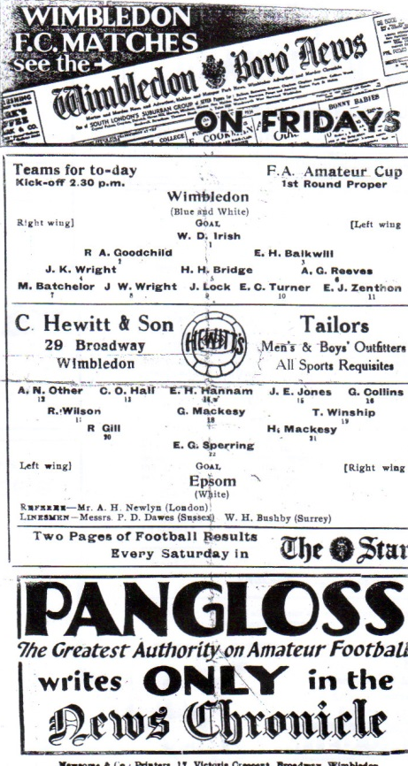
81 years ago today we made our final appearance in the First Round of the Amateur Cup. We had very little success in this competition over the years but in our three visits to the final rounds we drew the holders twice and the finalists once. Throw in a win at Ipswich Town and you will see that this was a tough competition but there must have been easier draws than Ilford, Wycombe and Wimbledon! Anyway, this time we were in front of 5,000 spectators at Plough Lane but conceded a goal in each half to depart the competition 2-0. (see programme pictured).

80 years ago this week we destroyed Dagenham Town by eight goals to three at West Street. This club had no connection to the current club which were founded directly after the Second World War, but they were their pre-war equivalent, playing at Glebe Road, Dagenham. Our nippy winger B.Harris had his best day for the club, scoring four times while Jackie Pullen scored three and Billy Neal got the other one.

70 years ago today we had a friendly match at West Street against Crawley. They were a tiny Mid-Sussex League team at this stage and only started to move up into the Sussex League in 1951 and then the Metropolitan League before reaching the Southern League in 1963. A Gordon Brogdale hat trick set us on our way with this 5-3 victory, even though it was only 1-1 at half time. I doubt we’d have the same success against them these days!

59 years ago today Johnny Bangs continued his superb 1956/57 season with a hat trick in our 5-0 win over Chesham United. Brian Jenkins scored the other two and both went on to greater things with other local clubs. Bangs joined us in the September but despite the late start he nearly broke Bill Goddard’s post war scoring record with 53 in 39 appearances! In goal for Chesham that day was Jim Morris, father of our record appearance holder Graham.

60 years ago this week and still on the subject of players who went on to have success at local clubs, we lost 4-1 at Maidenhead United, but our goal was scored by Ted Murphy who would famously score at each end in Tooting & Mitcham United’s famous F.A. Cup Third Round 2-2 draw at Sandy Lane against eventual winners Nottingham Forest in January 1959. He was also a member of Wimbledon’s 1963 Amateur Cup winning team.

3 years ago today we defeated Badshot Lea 3-2 at their temporary home of Weycourt, the ground of Godalming Town. This was the sixth of our club record twelve match league winning run and the real story was how the score line was so close as we should have won by about six! As it was Robbie Burns got two while Nathan Ayling scored the other goal.

Where’s Daryl?

For those of you wondering where Daryl Cooper-Smith is, the simple answer, as I write, is in Thailand on holiday!

However, even if he were here, he would be unable to play for us as a result of the ramifications of our match at Bedfont Sports in November.

Daryl was given a misconduct charge after patting the Assistant on the shoulder after being sent off, which was deemed to be physical contact with an official. In addition to the two game suspension he received for his sending off, the Surrey F.A. decided to suspend him for a ludicrous amount of time and how they actually came up with the figure of 82 days is beyond me. We expect him to become available once again in late February. He was also fined £135.

Apart from the obvious over-reaction in terms of the length of the penalty imposed by the County F.A. there is in my opinion a gross injustice in suspending anyone for a number of days instead of a number of matches. For example, if we had two months of snow from this point, he wouldn’t miss any more games. Meanwhile some clubs play more, or less matches over this period of the year (cough, cough Grand Drive, Chalky Lane) and the penalty for Daryl would be far less if he were at one of those clubs. This clearly has to change for the future and we will be taking this matter up with the Surrey F.A., although we have been advised that there is no point in appealing the penalty and have regrettably had to accept their decision as the penalty could have been increased!

Anyway, we thought it was fair to let you all know that this is why Daryl hasn’t been on the field recently.

Following on from this, both Glyn Mandeville and Matt Smith, who were also sent off that evening were fined £40 and given a two game touchline ban. They may even be sitting next to you in the stand tonight!

Epsom & Ewell Goalkeeper Hall of Fame
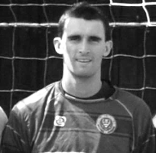
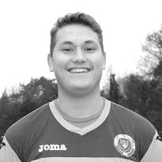
It occurred to me recently that we have a Club Hall of Fame on the website for appearances and goal scorers, but not for clean sheets kept by our goalkeepers.

So I have now added one and it is available, of course on our website. At the very top is Dave Hyatt who recorded 101 of them in 409 appearances. Michael Eacott and Adrian Jones are also on the list with 17 and 7 respectively and it goes without saying that we hope they continue to climb the list.

As the top of the chart looks a long way away and a bit daunting, I told Michael that his clean sheet percentage is better than Dave’s was. Unfortunately, our failure to keep one at Horley Town means that is no longer the case. Sorry big fella

Combined Counties League Premier Division Opponents
All-time Records
incl Monday 28th December | P | W | D | L | F | A | PPG | GD | Best  Win | Worst  Loss
Sutton Common Rovers | 10 | 8 | 1 | 1 | 24 | 11 | 2.50 | +15 | 4-0 | 1-4
Spelthorne Sports* | 4 | 3 | 1 | 0 | 13 | 5 | 2.50 | +8 | 6-2 | -
Horley Town | 27 | 19 | 5 | 3 | 59 | 26 | 2.30 | +33 | 6-0 | 1-3
Westfield | 17 | 11 | 3 | 3 | 39 | 27 | 2.12 | +12 | 6-1 | 0-4
Colliers Wood United | 21 | 14 | 2 | 5 | 45 | 28 | 2.10 | +14 | 4-0 | 0-3
Knaphill | 5 | 3 | 1 | 1 | 10 | 6 | 2.00 | +4 | 4-1 | 1-2
Bedfont Sports | 8 | 4 | 2 | 2 | 12 | 10 | 1.75 | +2 | 3-0 | 0-4
Guildford City | 15 | 8 | 1 | 6 | 27 | 21 | 1.67 | +2 | 4-0 | 1-5
Farnham Town | 12 | 6 | 2 | 4 | 21 | 21 | 1.67 | 0 | 3-1 | 1-4
Raynes Park Vale | 25 | 12 | 5 | 8 | 54 | 36 | 1.64 | +18 | 6-1 | 0-2
Hanworth Villa | 13 | 6 | 3 | 4 | 31 | 22 | 1.62 | +9 | 5-0 | 1-4
Hartley Wintney | 9 | 4 | 3 | 2 | 25 | 16 | 1.60 | +9 | 5-0 | 2-4
Camberley Town* | 86 | 38 | 20 | 27 | 155 | 119 | 1.56 | +36 | 9-1 | 0-4
Chessington & Hook | 27 | 11 | 9 | 7 | 52 | 41 | 1.56 | +11 | 6-0 | 1-3
Cove | 33 | 14 | 9 | 10 | 74 | 55 | 1.55 | +19 | 7-0 | 1-6
Windsor | 46 | 18 | 12 | 16 | 86 | 86 | 1.43 | 0 | 4-0 | 0-6
Badshot Lea | 16 | 6 | 3 | 7 | 27 | 32 | 1.31 | -5 | 3-0 | 0-4
Redhill | 32 | 13 | 2 | 17 | 60 | 69 | 1.28 | -9 | 7-2 | 2-8
Chertsey Town | 46 | 16 | 5 | 25 | 65 | 83 | 1.15 | -18 | 3-0 | 0-7
Ashford Town (Mx) | 16 | 4 | 2 | 10 | 22 | 41 | 0.88 | -19 | 3-0 | 0-5
AFC Hayes | 7 | 1 | 2 | 4 | 9 | 15 | 0.71 | -6 | 3-1 | 0-3
Grand Total | 476 | 220 | 91 | 164 | 896 | 772 | 1.58 | 124 | - | -
* includes one abandoned match v Camberley and one loss on penalties v Spelthorne

Centre page for results

Centre page for results



Ashford Town (Mx) F.C. – History
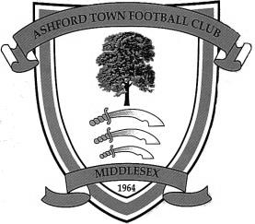
Until recently, it was assumed that Ashford Town Football Club was formed in 1964. However, new research has indicated the club was formed in 1958 as Ashford Albion and first competed in the Hounslow & District League. Albion won two consecutive promotions to reach the Premier Division of the Hounslow League and were still competing there when the club changed its name to Ashford Town in 1964. It was at this time that the club adopted its distinctive Tangerine & White colours. The club endured a difficult first campaign as the Town club and withdrew from the Premier Division, assuming the Reserve Team's place in Division Two.

Having rebuilt the club with a very young team, Ashford Town rapidly advanced through the various divisions of that League, absorbing Staines Youth Club FC on the way. Several individuals from that era have remained with the Club and now form the backbone of the Committee, including the Vice-Chairman and Secretary.

The Club were elected to the Surrey Intermediate League (Western) in 1967 and were promoted at the end of their first season. The Ash Trees were League Cup finalists in 1970-71 and League runners-up in 1972-73. In 1974-75, Ashford enjoyed their best season under the Management of ex-Fulham player Frank Reid, winning the League by three points from perennial contenders Merrow.

Although the championship eluded the Club in following seasons, it usually finished in the top four and prior to season 1982-83 an invitation was extended by Surrey County FA to become founder members of the Surrey County Premier League. The invitation was readily accepted and Ashford played their first match in the new league on 4 September 1982, drawing 0-0 away to Farleigh Rovers.

Almost from its foundation, the Club had aspirations to acquire its own ground and after one or two disappointments, this was achieved in August 1985, when a long lease was signed with Spelthorne Borough Council, enabling the Club to move to its present home at Short Lane, Stanwell. From what was nothing more than a field, the facilities were quickly developed, with the first match at Short Lane taking place in February 1986, following two postponements for snow. Floodlights were erected in September 1995, whilst the pitch is railed all round and partly walled, with standing covered accommodation, plus a purpose built 150-seater stand, built in 1998 (pictured). An additional 100 seats were installed on the opposite side of the ground to this stand in 2006, after the club won promotion to the Isthmian League Premier Division.

For both geographical and historical reasons, Ashford affiliate to both Middlesex and Surrey F.As and in 1989-90, their last season as an Intermediate Club, they reached the final of both County’s Premier Cup competitions, beating Farnham Town in the Surrey version, but losing to Willesden Hawkeye in the Middlesex final. Runners-up spot in the League was also secured and with it the opportunity to enter senior football, as members of the Combined Counties League, senior status having been granted in May 1990. It was at this point that the club changed its name to Ashford Town (Middlesex) FC, to avoid confusion with the Kent club of the same name.

During its ten year membership of the Combined Counties League, the Club never finished below sixth place, and after finishing 3rd and 2nd in seasons 1992-93 and 1993-94, it went on to win the League Championship for four successive seasons. It was a relative disappointment to only come 4th in 1998-99 even though the Club won the League Cup but a 5th championship in just six seasons was secured in 1999-00, along with the Middlesex Charity Cup, the first ever senior county cup honour. With the ground up to the required standard, Ashford took their place in the Isthmian League for season 2000-2001 and by finishing in 3rd place, secured promotion to Division 2 at the first attempt.

Further major improvements were made to the ground to enable the Club to be granted a B-grade and to take its place in the newly regionalised Division One of the Ryman League. A poor start saw the Club in the bottom echelons of the table but a number of new signings saw a significant improvement and a 17th place finish, which was an excellent performance after winning just one of the opening 16 league matches.

Further progress was made in 2003-04 as the Club finished 12th in Division 1 South. In the close season prior to 2004-05, the pitch has been completely re-laid to include both irrigation and drainage systems, at a cost of around £50,000, mostly financed by the Football Stadia Improvement Fund. Further medium term plans include new changing accommodation adjacent to the pitch, which will allow enlargement of the present clubhouse, and a hard surface floodlit training area.

The Club embarked upon new adventures in season 2004-05 in the Southern League for the first time, having been transferred over as a result of the FA restructure. The 4th Qualifying Round of the FA Cup was reached for

the first time and Mark Butler, renowned goal scorer in his day with Aldershot Town, Staines Town etc, was promoted from Assistant Manager to Manager following the resignation of Nathan Wharf in December 2004.

The play-offs were reached but resulted in a narrow defeat at Evesham United after extra time.

In 2005-06, Ashford went one better, finishing second in Division One West of the Southern League, to secure promotion to Step 3. This brought about a return to the Isthmian League for season 2006-07 and saw Ashford competing at their highest ever level. The season brought consolidation with the added bonus of reaching and winning the Westview (League) Cup Final when Ashford triumphed 4-1 over Dover Athletic at Bromley. The Reserves also lifted a trophy, securing the Middlesex Premier Cup.

Ashford built on this success, rallying from the foot of the table in November 2007 to narrowly miss a place in the promotion play-offs at the end of the 2007-08 season; a campaign which saw all of the club's senior sides challenge for honours.

The 2008-09 season saw Ashford begin the campaign in electrifying form, winning their opening six matches to top the table. Mark Butler's side followed this up with a fantastic FA Cup run which saw them come agonisingly close to eliminating Forest Green Rovers in the Fourth Qualifying Round at Short Lane. Rovers won the replay and went on to run Derby County close in the Third Round. Ashford endured a difficult winter, which saw them flirt with relegation, before a late resurgence saw the side safely into mid-table. The cup competitions added much adventure to the season, as Ashford followed up their exploits in the FA Cup with runs to the semi-finals of both the Middlesex Senior and Isthmian League Cups and end their campaign by defeating Conference Premier outfit Woking 3-2 at Metropolitan Police to win the Surrey Senior Cup.

The 2009-10 season saw Ashford make a reasonable start to the campaign, but the were shocked when manager Mark Butler tendered his resignation on Friday 23rd October, in order to take up the Manager's role at Margate FC, who were struggling at the foot of the table. Ashford appointed former Leicester City and Bradford City midfielder Jamie Lawrence as his replacement, and the Jamaican international immediately led his new charges on a twelve-match unbeaten run. However, issues off the pitch were causing problems for the club and a number of players, including leading goalscorer Byron Harrison left for Carshalton Athletic, where Mark Butler had accepted a coaching role after leaving Margate, where he had been in charge for just three months.

Ashford found scoring a problem after Harrison left and a dreadful run of form saw them go from the fringe of the play-off zone to battling relegation. Ashford went into their final match knowing a win would almost guarantee survival, while a draw would see them finish fourth from bottom - technically a relegation place, but certain to receive a reprieve owing to the demise of various other clubs. Sadly, a heavy defeat for Ashford, coupled with wins for Carshalton and Margate saw the latter two clubs survive - Margate receiving the reprieve for finishing fourth from bottom.

During the summer of 2010, the club were initially placed in the Central Division of the Southern League but were then offered the chance to remain at Step Three of the non-league pyramid. However, as this offer was as a direct replacement for defunct Southern League side Merthyr Tydfil, the decision was made that the vast increase in travelling would be too great a burden for the club and the club elected to remain in the Central Division. During this time, Bob Parker stepped down from his role as Chairman after twenty-eight years in the role. The club's home ground was renamed the Robert Parker Stadium in honour of Bob, who remains at the club as President.

The club entered a new era in the Central Division of the Southern League with Jamie Lawrence at the helm and with a mixture of established local players and new faces but the season was a challenging one. The club played some sparkling football at times and enjoyed an exciting run in the FA Trophy, reaching the Last 32 in the competition before losing at home to Dartford. However, League form was patchy and the club finished 16th. One bright spark was the club winning the Southern Combination Cup, defeating Hanworth Villa 1-0 in the Final.

Jamie Lawrence resigned as Manager in June 2011 and the club immediately appointed his assistant, Paul Burgess, to take the helm after more than 21 years at the club, including 683 First Team appearances. Despite having little time to do it and few resources at his disposal, "Burgo" assembled a young and exciting team. Although any hopes of a tilt at the promotion play-offs were dashed by a dreadful run where the club failed to win at home for four months, Ashford finished the season strongly, winning two Cup Finals in 48 hours. A memorable season was capped by the club being named winners of the Southern League Fair Play Award.

A relegation season followed in 2013/14 and Ashford returned to the Combined Counties League for 2014/15, but a slow start hampered their chances of an immediate return and they finished third.

Surrey Senior Cup
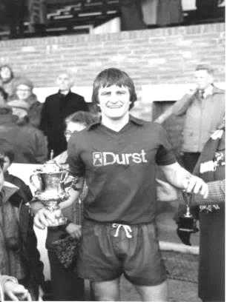
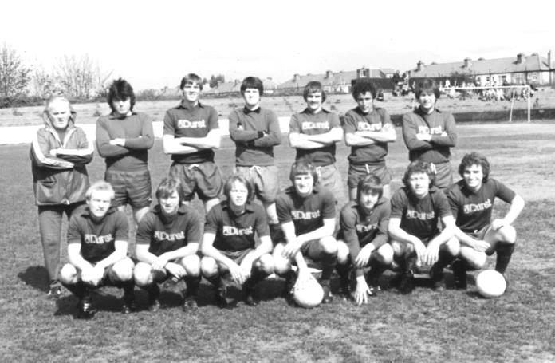
Second Round
Knaphill | 4-3 | Ashford Town (Mx)
Chipstead | 4-1 | Chessington & Hook United
Colliers Wood United | 1-3 | Whyteleafe
Corinthian Casuals | 1-1 | Egham Town
Corinthian Casuals won 4-2 on penalties
Croydon | 3-3 | Farnham Town
Farnham Town won 3-2 on penalties
Godalming Town | 1-0 | Guildford City
Horley Town | 2-2 | Badshot Lea
Badshot Lea won 4-3 on penalties
Leatherhead | 3-0 | Carshalton Athletic
Merstham | 3-0 | South Park
Met Police | 3-2 | Dorking Wanderers
Molesey | 2-1 | Raynes Park Vale
Redhill | 0-3 | Tooting & Mitcham United
Sutton United | 3-0 | Walton & Hersham
Walton Casuals | 1-1 | Kingstonian
Kingstonian won 9-8 on penalties
Westfield | 2-0 | Chertsey Town
Woking | 10-0 | Sutton Common Rovers
Third Round
Godalming Town | 12/1 | Tooting & Mitcham United
Whyteleafe | 12/1 | Farnham Town
Kingstonian | 13/1 | Leatherhead
To be played at Leatherhead F.C.
Badshot Lea | 13/1 | Merstham
Westfield | 19/1 | Woking
Met Police | 0-1 | Molesey
Knaphill | 13/1 | Chipstead
Corinthian Casuals | 12/1 | Sutton United

CCL Premier Division Club Directory
A.F.C. HAYES Telephone: 0208-845-0110 - Ground: Farm Park, Kingshill Avenue, Hayes, Middx. UB4 8DD - Colours: Blue and White Stripes/Blue/Blue

ASHFORD TOWN (Mx) Telephone: 01784-245908 - Ground: The Robert Parker Stadium, Short Lane, Stanwell, Middx. TW19 7BH - Colours: Tangerine & White Stripes/Black/Tangerine

BADSHOT LEA Telephone: 01252-320385 - Ground: Ash United FC, Shawfield Stadium, Youngs Drive, Shawfields Road, Ash, Hampshire. GU12 6RE - Colours: Claret/White/Claret

BEDFONT SPORTS Telephone: 0208-831-9067 - Ground: Bedfont Sports Club, Hatton Road, Bedfont, Middx TW14 8JA - Colours: Red & Black Hoops/Black/Red & Black Hoops

CAMBERLEY TOWN Telephone: 01276-65392 - Ground: Krooner Park, Wilton Road, Camberley, Surrey. GU15 2QW - Colours: Red & White Stripes/Blue/Red

CHERTSEY TOWN Telephone: 01932-561774 - Ground: Alwyns Lane, Chertsey, Surrey. KT16 9DW - Colours: Royal Blue & White Stripes/Royal Blue/Royal Blue

CHESSINGTON & HOOK UNITED Telephone: 01372-602263 - Ground: Chalky Lane, Chessington, Surrey. KT9 2NF - Colours: Blue/Blue/Blue

COLLIERS WOOD UNITED Telephone: 0208-942 8062 - Ground: Wibbandune Sports Ground, Robin Hood Way, Wimbledon. SW20 0AA - Colours: Blue & Black Stripes/Black/Black

COVE Telephone: 01252-543615 - Ground: Oak Farm Fields, 7 Squirrel Lane, Cove, Farnborough, Hampshire. GU14 8PB - Colours: Yellow/Black/Yellow

EPSOM & EWELL Telephone: 01737-553250 - Ground: Chipstead FC, High Road, Chipstead, Surrey. CR5 3SF - Colours: Royal Blue & White Hoops/Royal Blue/Royal Blue & White Hoops

FARNHAM TOWN Telephone: 01252-715305 Ground: Memorial Ground, Babbs Mead, West Street, Farnham, Surrey. GU9 7DY Colours: - Claret & Sky Blue /White/ Claret & Sky Blue

GUILDFORD CITY Telephone: 01483-443322 - Ground: The Spectrum, Parkway, Guildford, Surrey. GU1 1UP - Colours: Red & White Stripes/Black/Black

HANWORTH VILLA Telephone: 0208-831-9391 - Ground: Rectory Meadows, Park Road, off Hounslow Road, Hanworth, Middlesex. TW13 6PN - Colours: Red & White Stripes/Black/Black

HARTLEY WINTNEY Telephone: 01252-843586 - Ground: Memorial Playing Fields, Green Lane, Hartley Wintney, Hants RG27 8DL - Colours: Orange & Black/ Orange /Orange

HORLEY TOWN Telephone: 01293-822000 - Ground: The New Defence, Anderson Way, Court Lodge Road, Horley, Surrey. RH6 8SP - Colours: Claret & Sky Blue/Claret/Claret

KNAPHILL Telephone: 01483-475150 - Ground: Brookwood Country Park, Redding Way, Lower Guildford Road, Knaphill, Surrey. GU21 2AY - Colours: Red/Black/Red

SUTTON COMMON ROVERS Telephone: 01932-866386 - Ground: Sutton United FC, Gander Green Lane, Sutton, Surrey SM1 2EY - Colours: Yellow/Black/Black

RAYNES PARK VALE Telephone: 020-8540-8843 - Ground: Prince Georges Playing Field, Grand Drive, Raynes Park, London. SW20 9NB - Colours: Blue/Blue/Red

REDHILL Telephone: 01737-762129 - Ground: Kiln Brow, Three Arch Road, Redhill, Surrey RH1 5AG - Colours: Red and White Stripes/Black/Red

SPELTHORNE SPORTS Telephone: 01932-961055 - Ground: Spelthorne Sports Club, 296 Staines Road, Ashford Common, Ashford, Middx. TW15 1RY - Colours: Light & Dark Blue/Dark Blue/Light Blue

WESTFIELD Telephone: 01483-771106 - Ground: Woking Park, Kingfield Road, Woking, Surrey. GU22 9BA - Colours: Yellow/Black/Black

WINDSOR Telephone: 01753-860656 - Ground: Stag Meadow, St Leonards Road, Windsor, Berks SL4 3DR - Colours: Red/Red/Red

Every Opponent A-Z
Over the years we have played many, many different opponents. Exactly how many is a difficult question, as it all depends on your definition. Are Camberley & Yorktown different to Camberley Town, or are Epsom Town different to Epsom F.C. or Epsom & Ewell F.C.?

In my analysis I have classed them as the same team, and will work through them all from A to Z. Some we have played many times, whilst others we have met just once or twice. Enjoy!

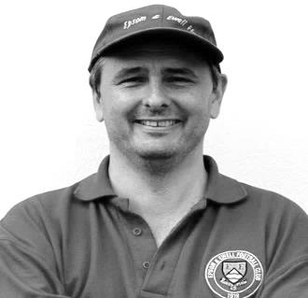
Rest of London League: Played 1 - W1 D0 L0 - F3 A0 - PPG - 3.00 - Perfect

Back in 1927/28 we won the London League for the one and only time in our history, although we would be runners-up on five other occasions. As was customary in those days, we hosted a team of players representative of all the other teams in the League to open our season and we beat them 3-0, proving that a team is usually better than a group of individuals. Nothing changes!

Ringmer: Played 2 - W1 D0 L1 - F4 A2 - PPG - 1.50 - Average

Ringmer have been a Sussex League club for many years, and our paths have remained fairly distant. Our two meetings both came in the F.A. Vase, the first of which was in 1977/78 when we hosted them in a Third Round tie, winning 4-0 at West Street with two goals from Steve Delaney, added to others from Tony Coombe and Richard Parkin. This put us in the Fourth Round for the first time since our Wembley run three years previously but we then bombed out 0-3 at home to Eastbourne United; a team we beat easily home and away in the League that season!

Ringmer had to wait 34 years to get their revenge, defeating us 2-0 at the Anchor Ground in a 2011 second qualifying round tie in a match where the opposition belied their lowly league position and two second half goals did for us when for a while it looked as though we might hold out at 0-0. Until Dre Grobler was harshly sent off, that is!

We have also visited for a pre-season friendly, winning 2-0 in 2003/04 and they continue in the Sussex League, now renamed the Southern Combination League, to this day.

Romford: Played 4 - W1 D1 L2 - F9 A17 - PPG - 1.00 - Poor

After the Second World War, Romford were a very big club. They played at Wembley Stadium in the first Amateur Cup Final to be played at Wembley Stadium in 1949 in front of 100,000 spectators, losing 1-0 to Bromley and were a powerful Isthmian League giant before turning professional, joining the Southern League and even submitting numerous applications to join the Football League in the days when promotion wasn’t automatic. Before the war they spent a couple of years in the London League from 1929-31, which is where we met them. They played then, as in the glory days, at the enormous Brooklands ground; a half football and half greyhound racing facility in front of enormous crowds, even back then.

Our first meeting was at West Street on 14th September 1929, where we led 4-0 at half time but had to settle for a 4-2 win. The reverse situation happened on our first visit to the Essex ground as we too trailed by four goals at the interval, and although we also got two goals back, we still lost 5-2.

The following season we trailed 2-1 at half time at West Street but managed to record a 3-3 draw in the end, but the strangest meeting between the clubs was our last, on 14th March 1931 at Brooklands. An even match was level at half time and remained goalless after an hour, yet somehow Romford had scored seven times to win 7-0 by the final whistle!

Romford’s ambition proved to be their downfall. Owning a massive ground had enormous overheads and the plan was to move to a new, more modern ground in the late seventies, but it never came. They sold their ground in 1975 and were allowed to remain until 1977 but with a new ground hardly started and money running out they folded in 1978.

But they weren’t quite done yet. In common with other big Southern League clubs of the day like Bedford and Maidstone they have reformed since, joining the Essex Senior League in 1992. They merged with Collier Row in 1995/96 but within two seasons they were just renamed Romford as they effectively and clinically usurped their former landlords who folded. However, success was hard to come by and they also lost the Sungate ground soon after. They dropped out of the Isthmian League early in the new Millennium as a result but returned in 2009 and have been there since, ground sharing currently with Thurrock F.C. right next door to the M25.

I am guessing that they still harbour plans to secure a ground of their own, although if I were Thurrock, I’d be worried after what happened to Collier Row!

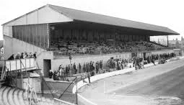
How about that for a main stand! The main feature of the Brooklands ground

Royal Artillery Mechanical Corps Aldershot: Played 1 - W1 D0 L0 - F3 A0 - PPG - 3.00 - Perfect

We only met this armed forces unit once, in the F.A. Cup Extra-Preliminary Round on 4th September 1937 winning 3-0 but we didn’t break through until the second half as Jackie Pullen scored twice and Jimmy Jones got the other one from the spot.

Royal Electrical Mechanical Engineers Putney: Played 1 - W1 D0 L0 - F9 A2 - PPG - 3.00 - Perfect

In 1945/46 we had of course just reformed after World War Two and were in a small London League division of nine teams, which became eight following the withdrawal of Acton. There were many spare dates for friendlies and plenty of Forces teams still in existence, of which one was the Putney based Mechanical Engineers, but they were badly out of their depth and were crushed 9-2. Gordon Brogdale would score 44 goals in 32 appearances for us this season, the sixth best seasonal tally in our history and he registered five of the goals here with Frank Adey (2), Syd Tingey and an own goal completing the formalities! Friendlies were classed as official challenge matches up until 1960 in our records as the club counted them back then and who am I to disagree!

Player Sponsorship
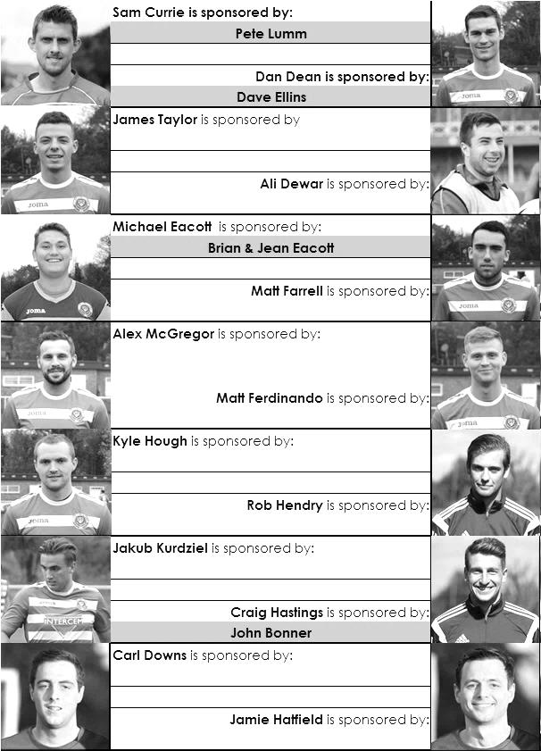

Here is the current list for the 2015/16 season showing all of our players and Management that are currently available for sponsorship this season.

Sponsorship costs just £40 and it is easy to do. Just select a player who has not been previously sponsored and let a Committee Member know that you would like to sponsor them. Beware though. Until we have received the money it is possible for someone to jump in front of you, so don’t delay, sponsor today!

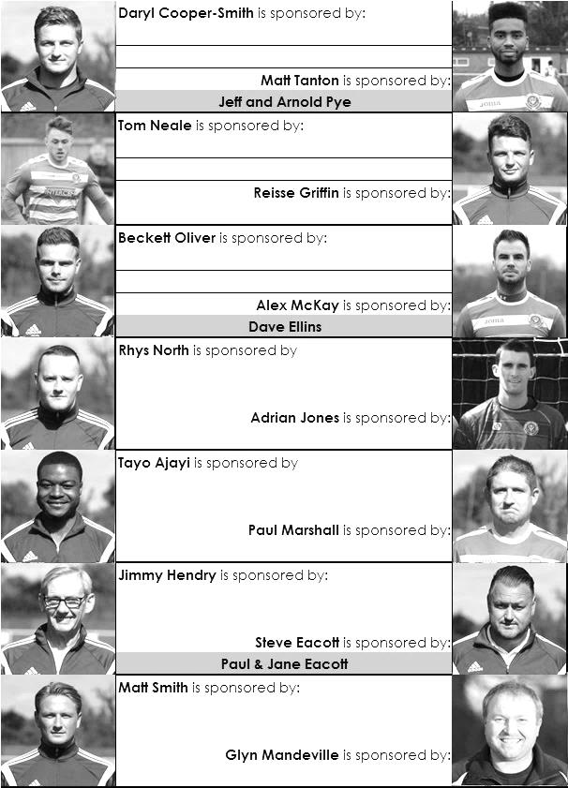

F.A. Vase
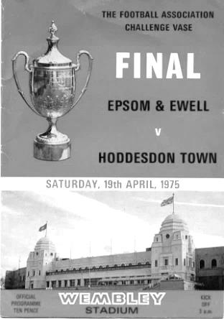
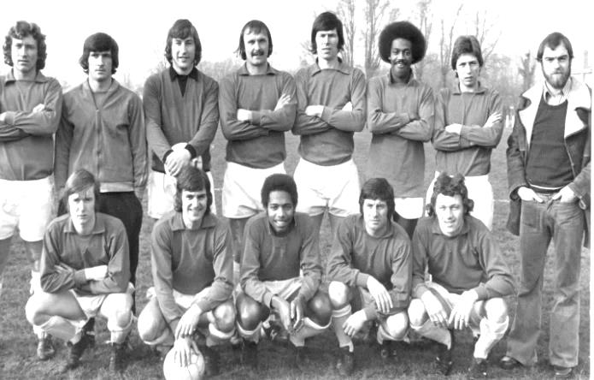
Third Round – Original date for fixtures – 12th December
Marske Utd (played at Team North’bria) | 2-1 | Team Northumbria
Sunderland RCA | 4-0 | Tadcaster Albion
Newton Aycliffe | 12/1 | Atherton Collieries
South Shields | 12/1 | Morpeth Town
North Shields | 1-1+ 1-0 | Runcorn Town
Dunston UTS (played at Consett FC) | 1-0 | Seaham Red Star
Alsager Town | 0-2 | AFC Wulfrunians
St Andrews | 1-5 | Leicester Nirvana
Handsworth Parramore | 1-2 | Cleethorpes Town
Pinxton | 3-4 | Nuneaton Griff
Walsall Wood | 0-3 | Alvechurch
Uttoxeter Town | 3-4 | Coleshill Town
Hereford | 2-0 | Brocton
Saffron Walden Town | 2-3 | Berkhamsted
FC Broxbourne Borough | 12/1 | Bowers & Pitsea
Hullbridge Sports | 2-0 | Stanway Rovers
AFC Dunstable | 4-0 | Basildon United
Edgware Town | 0-3 | Ipswich Wanderers
Yaxley | 3-4+ | Sleaford Town
Hertford Town | 0-2 | FC Romania
Colliers Wood United | 1-3 | Hartley Wintney
Thame United | 1-2 | Kidlington
Ascot United | 0-0+ r1-4 | Camberley Town
Lordswood | 1-5 | Ashford United
Eastbourne Town | 2-3 | Sutton Common Rovers
Tadley Calleva | 2-2+2-4+ | Newport (IOW)
Canterbury City | 1-3 | Knaphill
Moneyfields | 0-0+ 2-0 | Brimscombe & Thrupp
Buckland Athletic | 1-2 | Bradford Town
Highworth Town | 1-5 | Salisbury
Welton Rovers | 12/1 | Bodmin Town
Bristol Manor Farm | 7-1 | Hengrove Athletic

F.A. Vase - (league positions include 9th January matches)
Fourth Round – Original date for fixtures – 9th January
Cleethorpes Town | 2-1 | Alvechurch
Northern Counties East – 5th |  | Midland – 2nd
Hereford | 16/1 | Leicester Nirvana
Midland – 1st |  | United Counties – 1st
South Shields / Morpeth Town | 16/1 | North Shields
 |  | Northern – 10th
Coleshill Town | 16/1 | Dunston UTS
Midland – 13th |  | Northern – 4th
AFC Wulfrunians | 2-3 | Nuneaton Griff
Midland – 6th |  | STEP 6 - Midland Division 1 – 5th
Sunderland RCA | 16/1 | Sleaford Town
Northern – 9th |  | United Counties – 10th
Newton Aycliffe /  Atherton Collieries | 16/1 | Marske United
 |  | Northern – 7th
FC Broxbourne Borough /  Bowers & Pitsea | 16/1 | Sutton Common Rovers
 |  | Combined Counties – 10th
Kidlington | 16/1 | Knaphill
Hellenic – 3rd |  | Combined Counties – 14th
Newport IOW | 16/1 | Ashford United
Wessex – 9th |  | Southern Counties East – 3rd
Moneyfields | 16/1 | Bristol Manor Farm
Wessex League – 16th |  | Western League – 1st
FC Romania | 1-2 | Camberley Town
Essex Senior – 3rd |  | Combined Counties – 4th
AFC Dunstable | 10/1 | Salisbury
South Midlands – 2nd |  | Wessex – 1st
Berkhamsted | 4-2 | Hullbridge Sports
South Midlands – 7th |  | Essex Senior – 9th
Hartley Wintney | 16/1 | Bradford Town
Combined Counties – 2nd |  | Western League – 8th
Welton Rovers / Bodmin Town | 16/1 | Ipswich Wanderers
 |  | Eastern Counties – 11th

Match and Ball Sponsorships – 2015/16
Opponent | Date | Match Sponsor | Match Ball Sponsor
Hoddesdon Town | 18/07/15 | Geoff Dyke
Windsor | 08/08/15 | Club President - Stella Lamont
Erith & Belvedere (FAC) | 16/08/15 | Committee Member - Mike Lovett
Raynes Park Vale | 31/08/15 | EEFC Management Committee
Colliers Wood United | 08/09/15 | Bookham Building Shop – www.buildingshop.co.uk
AFC Hayes | 19/09/15 | John Bonner
Farnham Town | 26/09/15 | Ezara and Inaya Beddoe – our youngest supporters!
Chertsey Town | 17/10/15 | Club Media Officer – Richard Lambert
Dorking Wanderers (SSC) | 20/10/15 | Tony Ferdinando
Chessington & Hook United | 07/11/15 | Paul Merritt
Hanworth Villa | 21/11/15 | Maggie Beddoe
Guildford City | 05/12/15 | Pete Lumm
Sutton Common Rovers | 19/12/15 | Marvin Hough
Ashford Town (Mx) (LC) | 12/01/16
Spelthorne Sports | 16/01/16
Hartley Wintney | 30/01/16
Redhill | 02/02/16 | David Lawton
Bedfont Sports | 13/02/16
Horley Town | 27/02/16
Knaphill | 12/03/16
Cove | 15/03/16
Westfield | 26/03/16
Badshot Lea | 09/04/16
Camberley Town | 16/04/16
Ashford Town (Mx) | 30/04/16 | Brian Eacott
For League, League Cup and Surrey Senior Cup Matches:
Match sponsorship - £40.00 Match ball sponsorship - £25.00. Combined £55.00.
For F.A. Cup and F.A. Vase matches:
Match sponsorship - £50.00 Match ball sponsorship - £30.00. Combined £65.00.

Sponsorship includes: ( x2 for match, x3 for match and ball )

Admission, programmes, hospitality, advertising and mascot for the day ( if required ).
If you are interested, just speak to a Committee Member, or drop me an email at: richard.c.lambert@gmail.com


We also thank our Kit Sponsors INTERCEM

#loveastat
Thanks to Tony Coome, a supporter for the last few years and no connection to our former player and Assistant Manager, who mentioned that our first goal against Sutton Common Rovers was our fiftieth League goal of the season. It got me thinking, when had we last done this?

There are two ways of answering this question. One of these is by a certain date. Did you know that we have NEVER scored fifty League goals before Christmas before!! This caught me by surprise!

The other way is in terms of the number of league matches required to reach fifty goals, we took 21 this season. We also did this in 2007/08 but had only scored 50, while this year we have scored 52, so I went further back and it took me further than I thought, all the way back to 1974/75, when we reached fifty goals in our thirteenth match!

Even that isn’t our club record as in 1926/27 we got there in just our tenth match, on the way to recording a club record 115 goals in just a 24 game season! Obviously goals were a little easier to come by in those days and we beat our current 21 game mark for 14 seasons in a row from 1925-39! However, apart from 1926/27 and 1974/75 we have never broken 100 and at the half way stage this term we are at 52, so here’s hoping!

Club Fund Raising Evening – 23rd January
Following our trip to Windsor on 23rd January we will be holding a Categories Quiz Evening with local entertainer Martin Firmo, who is a former player at this level and will provide entertainment of the highest quality. The format is slightly different from a traditional quiz and so there is a bit of novelty value too!

The evening will be at a convenient local venue as it is to be held at the Epsom Common Working Mens Club; at the Stamford Green end of Epsom and entry is just £10. Please consider getting a team together and coming along. The beer is cheap, it’s local and you will get to meet the players too, so it’s all good!

The evening will not start until 7.30 so you have plenty of time to watch the game and get back in time for what promises to be an interesting evening. Please speak to a Committee Member for further details.

Salts Super Six Predictor
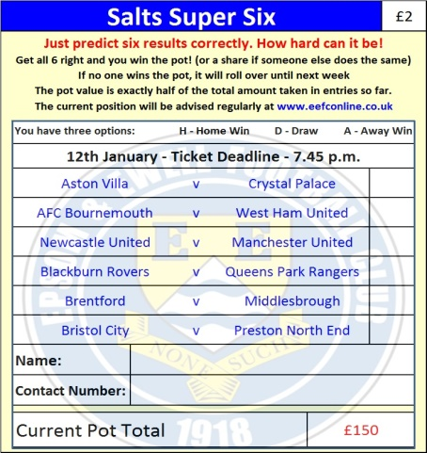
The Salts Super Six Predictor Competition is live again and the tickets are on sale at today’s game. We have three from the Premier League and three from the Championship today.

The competition is easy to play! To win, you simply need to predict the results of the six matches correctly from the three options, fill in the form and make sure it is back with our sellers before the deadline on the ticket.

If you are a club regular, you just need to place your name on the sheet, although if you aren’t, then we’ll need a contact number from you too. We will announce any winners on the website within three working days, so don’t worry we won’t miss you!

The jackpot is now at £150 and who knows how high it could go this time!

Please note that if there is more than one winner, the prize pot would be shared between the winners. All you need to do now is have a go, as many times as you like!

Good luck!

Combined Counties League Cup – Third Round
Tuesday, 12th January 2016 - Kick-off 7.45 p.m.
Epsom and Ewell  (Royal Blue & White hoops) | V |  | Ashford Town (Mx)  (Tangerine, White, Black)
Squad | NUMBERS |  | Squad
Michael Eacott |  |  | Tyler Tobin
Sam Currie |  |  | Josh Andrew
Alex McKay |  |  | Alex Fisher
Craig Hastings |  |  | Will Boye
Dan Dean |  |  | Russell Canderton ©
Carl Downs |  |  | Scott Elgar
Reisse Griffin |  |  | Mark Bitmead
© Matt Farrell |  |  | Max Webb
Kyle Hough |  |  | Dan Fleming
Tom Neale |  |  | Tom Brunton
Matt Ferdinando |  |  | Jack Beadle
James Taylor |  |  | Samad Kazi
Beckett Oliver |  |  | Scott Weight
Rob Hendry |  |  | Bradley Wainwright
Matt Tanton |  |  | Bayley Mummery
Savvas ‘Agi’ Panayiotou |  |  | Scott Harris
Adrian Jones
Rhys North
Alex McGregor
Matt Smith
Jamie Hatfield
Glyn Mandeville | MANAGER |  | Ben Murray
Matt Smith | ASSISTANT |  | Mark Green
Steve Eacott / Alex McKay / Jimmy Hendry | COACHES / PHYSIO |  | Pat Munns
REFEREE: C.Kissi (London)
ASSISTANTS: M.Ford (Sutton), R.Wells (Coulsdon)

OUR NEXT VISITORS TO HIGH ROAD ARE:
Spelthorne Sports

Saturday 16th January 2016 - Kick-off 3.00 p.m.
Combined Counties League – Premier Division

